  AFRICAN LEADERSHIP DEVELOPMENT | Abstract  The African Leadership Development segment of SICNI’s Public Opinion Poll captures the perceptions of Nigerians regarding leadership performance, credibility, and the qualities most valued in governance. Conducted in Lagos, Enugu, Edo, Bauchi, Kano, and the FCT, the study reveals widespread dissatisfaction with leadership delivery and a strong public demand for transparency, accountability, and integrity. Findings offer actionable insights for designing targeted interventions to nurture credible, visionary leaders capable of driving national development.

Introduction
Leadership has long been consistently identified as one of Africa’s most urgent development challenges, with governance quality shaping the trajectory of economic progress, social stability, and citizen welfare. In line with its mandate to catalyze positive leadership change, SICNI commissioned a Public Opinion Poll (POP) to gather direct insights from Nigerian citizens on leadership credibility, performance, and expectations.
The research objective was to identify leadership gaps, highlight public priorities, and provide evidence-based recommendations for developing credible, accountable, and visionary leaders.
The study was conducted only in Nigeria, covering selected states—Lagos, Enugu, Edo, Bauchi, Kano, and the FCT—chosen to reflect regional diversity. Using stratified random sampling, the survey ensured representation across gender, age groups, education levels, socio-economic status, and rural–urban divides.
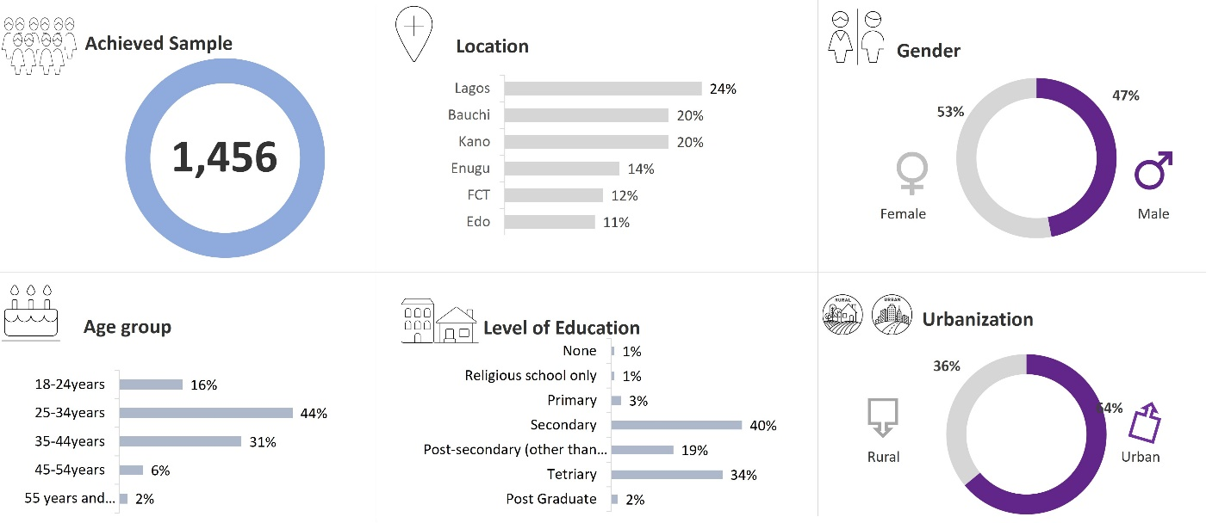
Data was collected through 30-minute structured, face-to-face interviews in strategically selected urban and rural locations, resulting in a dataset that reflects the voices of a diverse cross-section of Nigerians.

Research Findings
The survey results point to the following critical insights into the current landscape
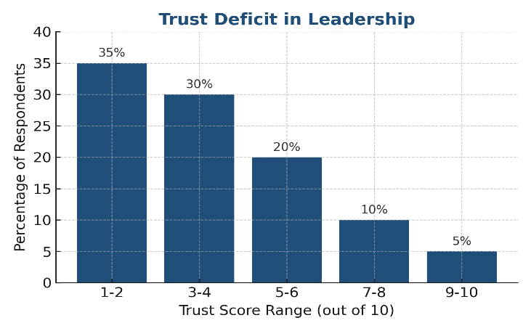
1. Trust Deficit in Leadership
Survey results reveal that a significant share of respondents rate leadership trustworthiness very low, with a large cluster giving leaders scores between 1–4 out of 10. This shows that skepticism about leaders’ intentions is deeply rooted in the public consciousness.

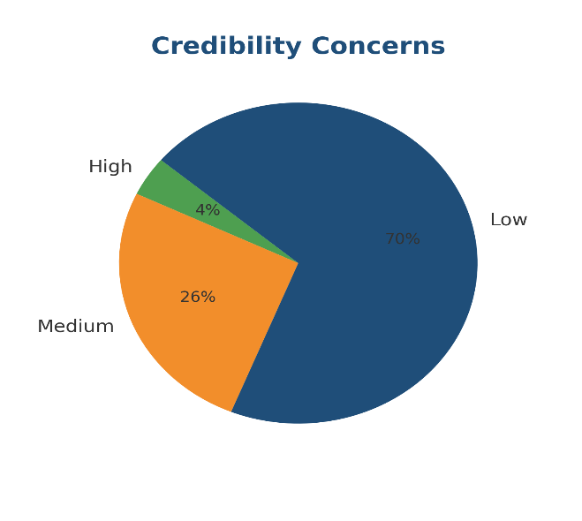
2. Credibility Concerns
Only a small minority view political leaders as “highly credible.” Most respondents categorize them as unreliable, raising serious questions about their ability to fulfill promises and lead with integrity.

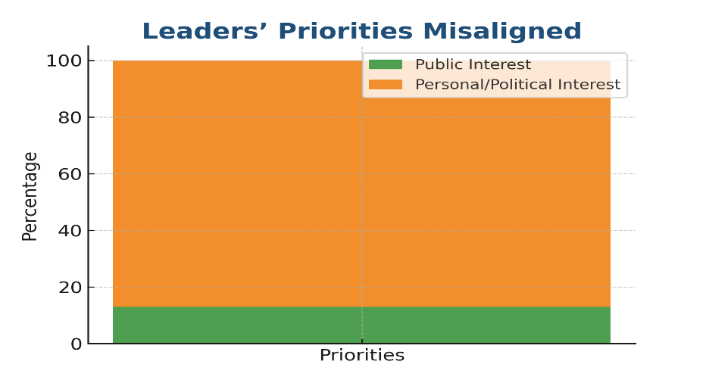
3. Leaders’ Priorities Misaligned
A striking majority believe leaders act in self-interest or for political survival rather than the public good. This perceived disconnect drives frustration and disengagement among citizens.
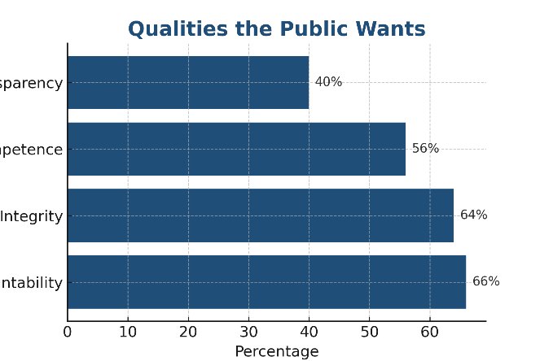
4. Qualities the Public Wants
When asked what qualities they most desire in leaders, respondents overwhelmingly pointed to accountability, integrity, competence, and transparency. These traits form a consistent pattern across regions, suggesting a shared leadership ideal.

Analysis

The survey results paint a picture of deep disillusionment with political leadership. The trust deficit is not simply a perception problem—it is rooted in consistent experiences of unfulfilled promises and governance decisions perceived as self-serving.
Low credibility scores across all surveyed regions suggest that distrust cuts across socio-economic and geographic lines. The fact that the public consistently demands accountability, integrity, competence, and transparency indicates a shared vision of good leadership but also underscores how far current realities are from this ideal.
This widespread dissatisfaction creates both urgency and opportunity: citizens are ready for credible leaders, but institutional mechanisms for finding and elevating such leaders are weak or absent.

Proposed Intervention
In response to these findings, SICNI proposes the following actionable strategies for meaningful change:
- Leadership Talent Identification Program
 | A structured process to spot credible, competent individuals in communities and professional sectors, using community nominations, peer review, and performance-based assessments.
- Ethics and Governance Bootcamp
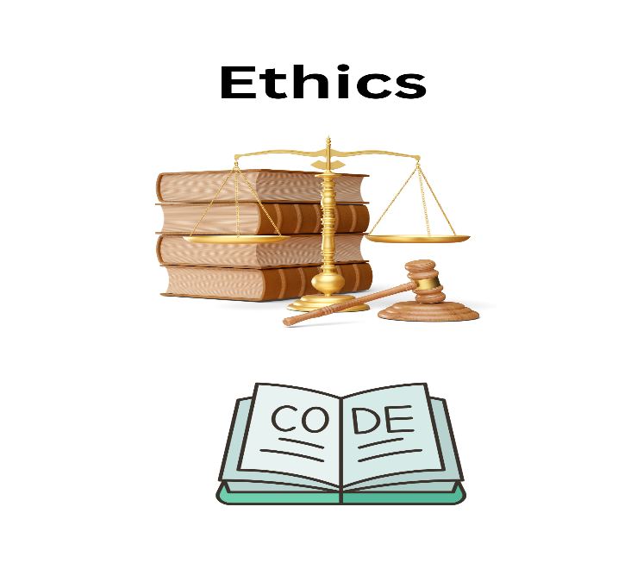 | Intensive short courses in leadership ethics, public finance management, and transparency tools for emerging leaders.

- Public Endorsement Platform
 | A SICNI-managed digital platform where citizens can track, endorse, and support individuals who demonstrate integrity and commitment to public service.

- Advocacy for Leadership Vetting Mechanisms
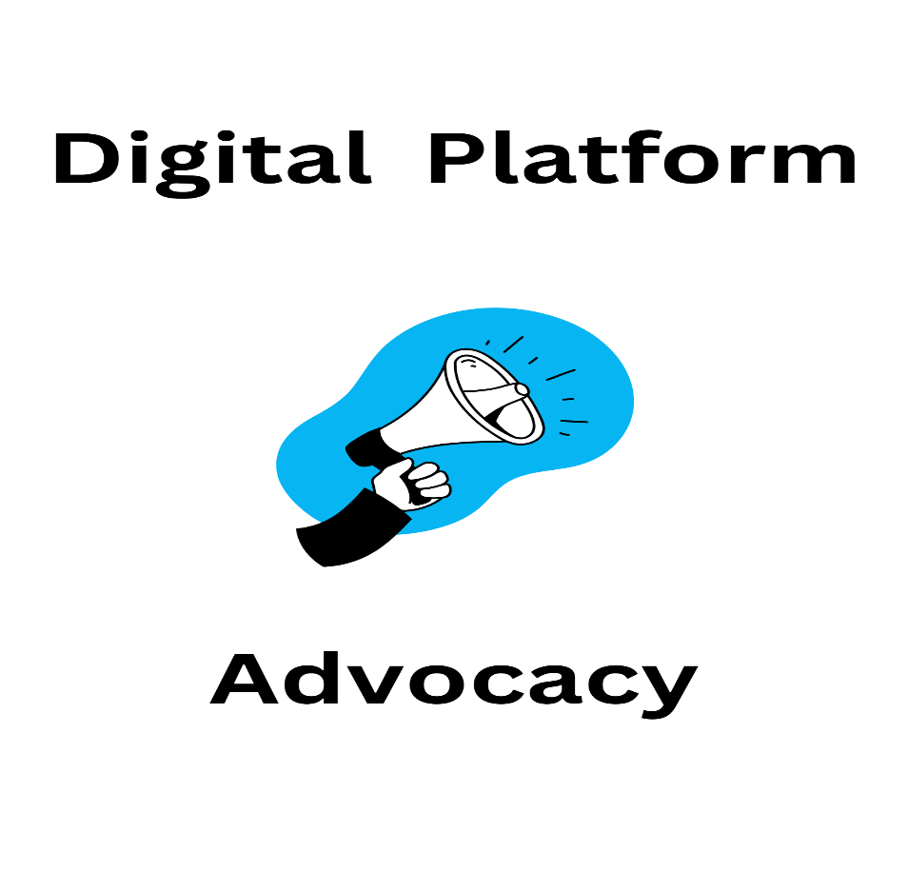 | Partnering with electoral bodies and civil society to push for stricter candidate evaluation criteria.

